**BEEE LAB EVALUATION**

**UID : 19BCS3884**

**SEM : 1st**

**SEC : BIG DATA (B)**

**AIM:**

Design a system for a gift-box such that whenever it is opened, it produces sound for 1000 ms and blinks red and green LEDs alternatively, as long as it is open.

**CIRCUIT DIAGRAM:**

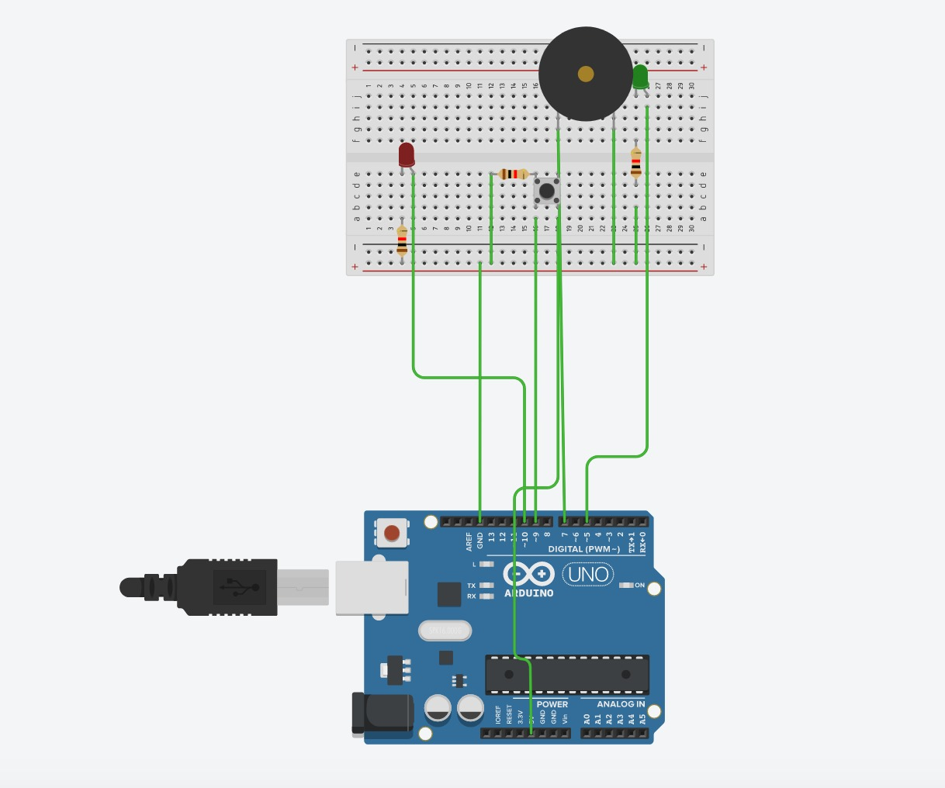

**Theory Concept :**

A system that automatically produces a sound of 1000ms and blinks red and green LED’s alternatively whenever the gift box is opened as long.

In this we will use Arduino in such a way that whenever push button is pressed the LED’s and the buzzer will be on and when it will not be pressed they will turn off automatically.

**Learning and observations:**

Following observations were recorded during the experiment:

1. Turning off and on LED’s and buzzer
2. Arduino used 5V supply
3. Buzzer and LED’s work simultaneously

**Problems and troubleshooting:**

Experiment is performed without any problem

**Precautions:**

The following precautions need to be considered while performing this experiment:

1. The connections of the USB in both the PC and the ARDUINO UNO board should be snug.
2. The USB ports of the PC and the ARDUINO UNO should be in a working condition.
3. The sketch should be logically and syntactically correct and germane to the experiment that needs to be performed.
4. The correct serial port should be selected that is the one through which the ARDUINO UNO has been connected.
5. Look for errors during compilation and upload of the executable to the ARDUINO UNO.
6. Do not open more than one instance of the ARDUINO IDE at a time.

**Learning Outcomes:**

The various learnings as the outcome of performing the above-mentioned experiment are:

1. Ability to identify and connect the push button with the ARDUINO through proper connections using a breadboard.
2. Code and circuit both are correct because of which program in Arduino working correctly.